**NAME: SAHANA S**

**REG NO: 192321131**

**COUSRE CODE:ITA0205**

**COURSE NAME: WEB TECHNOLOGY**

EXERCISE 1:

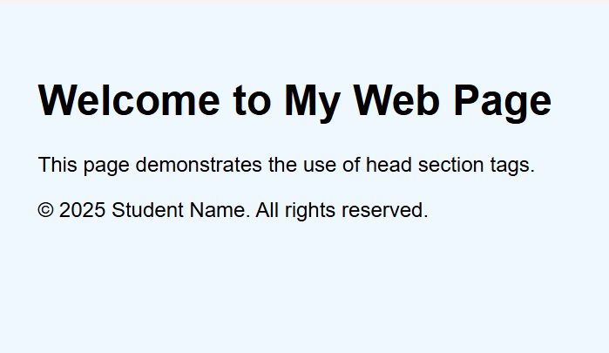

EXERCISE 2:

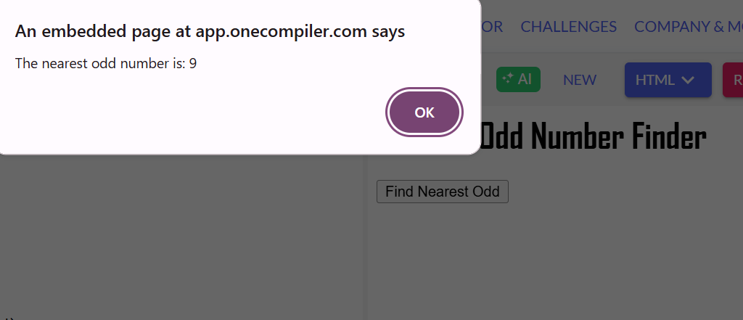

EXERCISE 3:

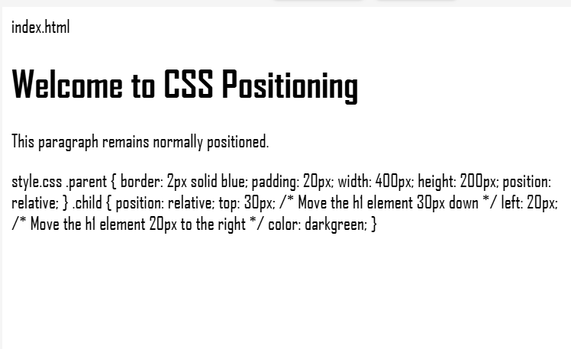

EXERCISE 5:

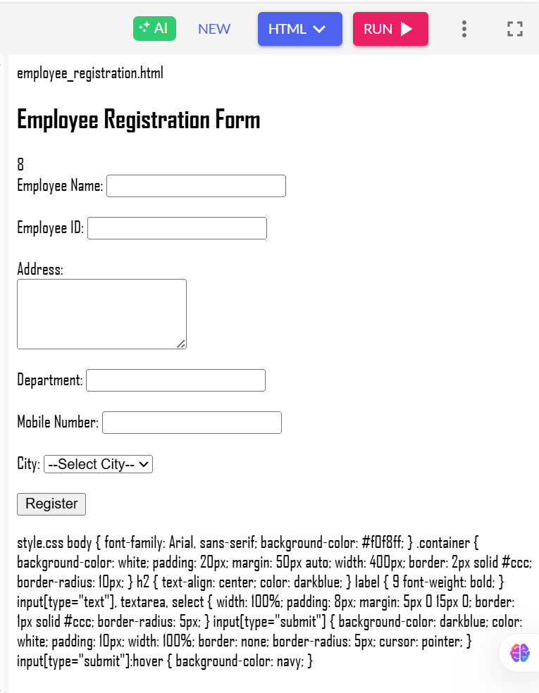

EXERCISE 6:

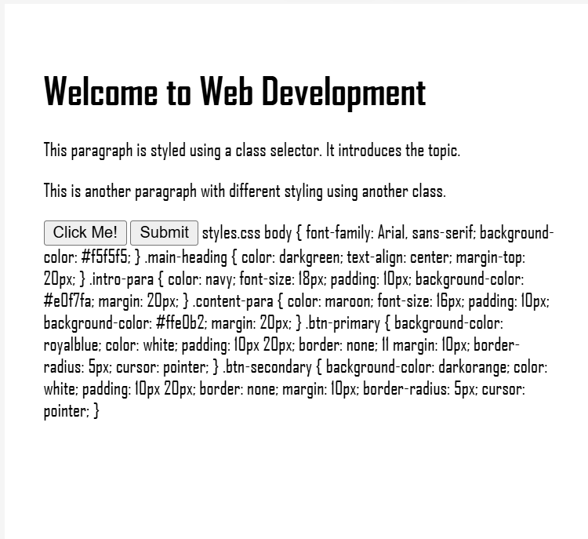

EXERCISE 7:

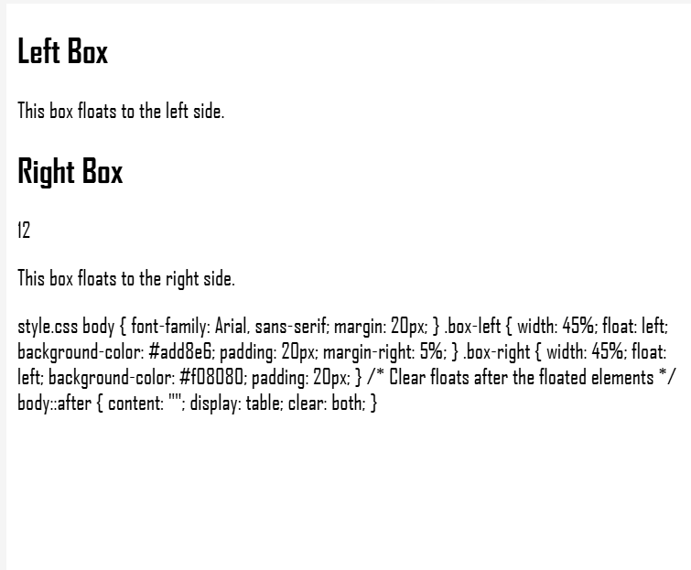

EXERCISE 8:

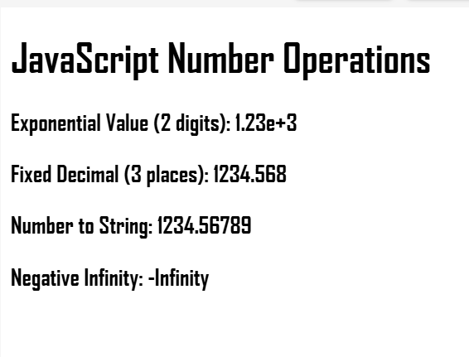

EXERCISE 9:

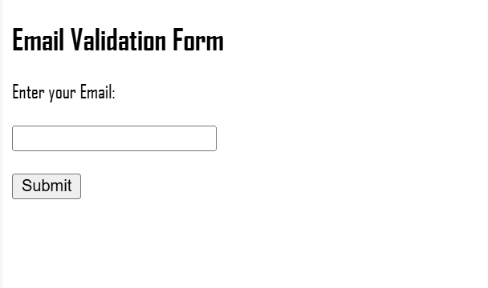

EXERCISE 10:

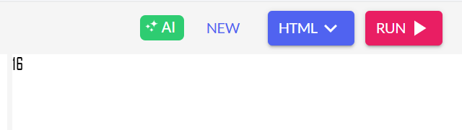

EXERCISE 11:

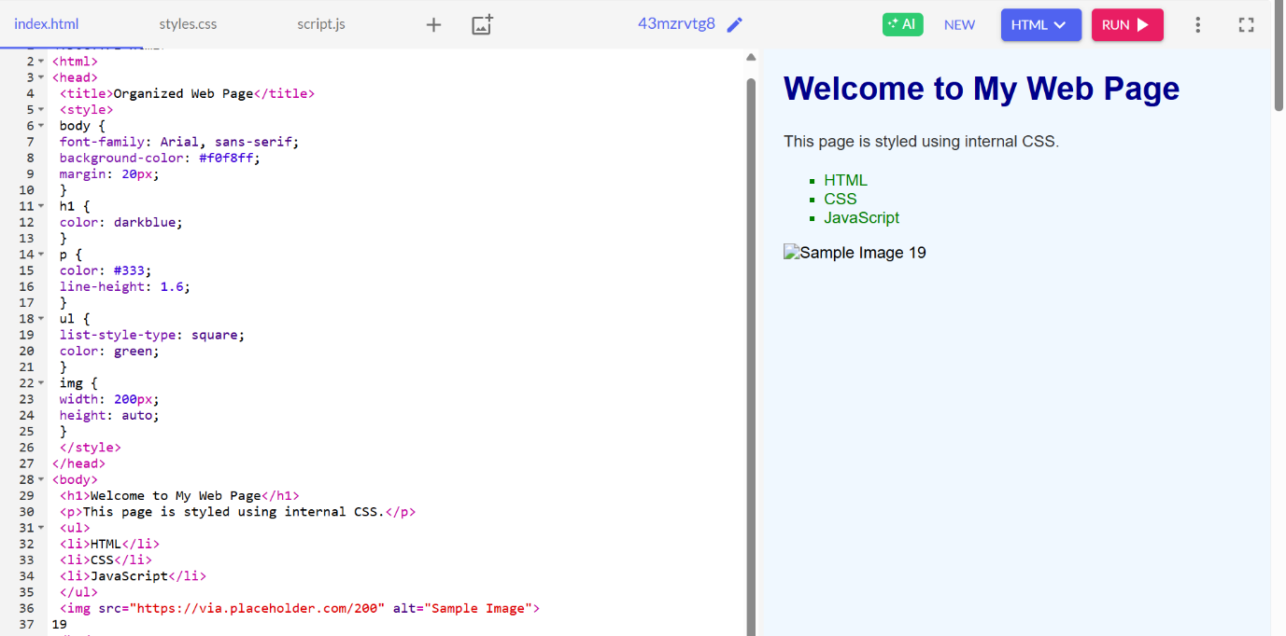

EXERCISE 12:

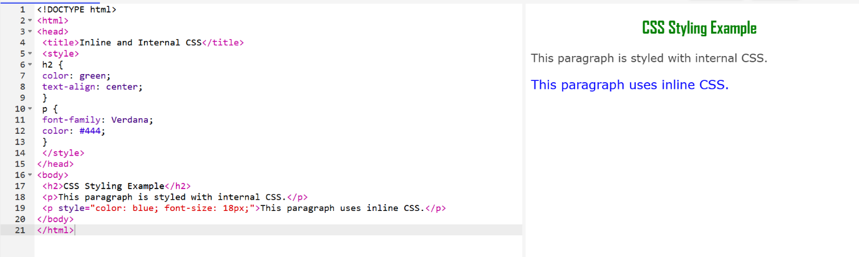

EXERCISE 13:

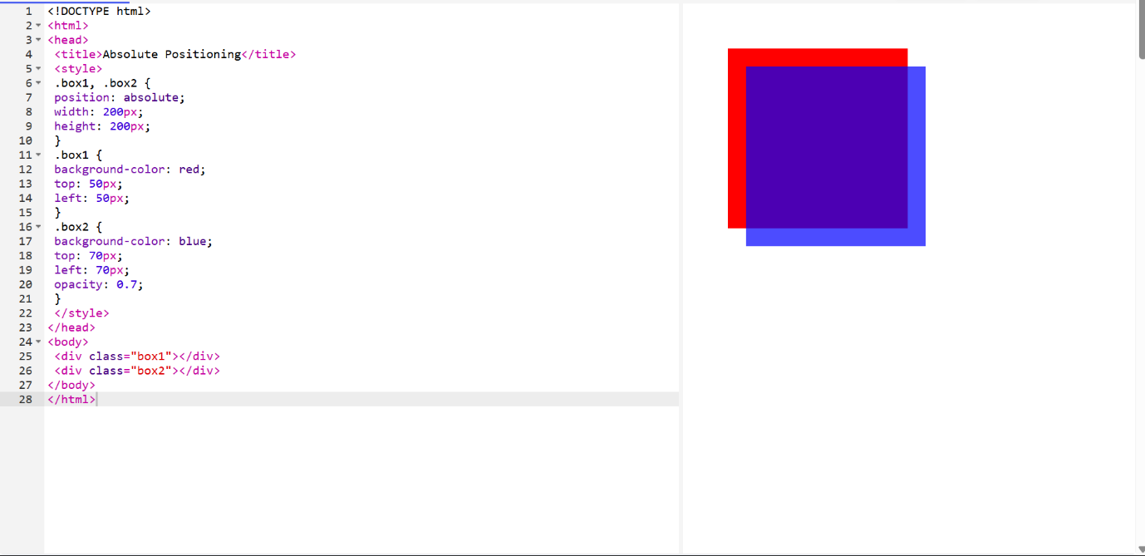

EXERCISE 14:

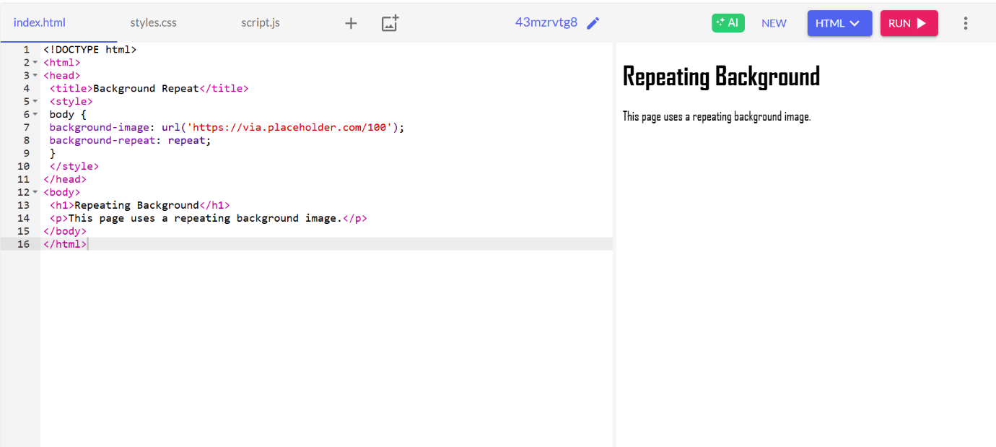

EXERCISE 15:

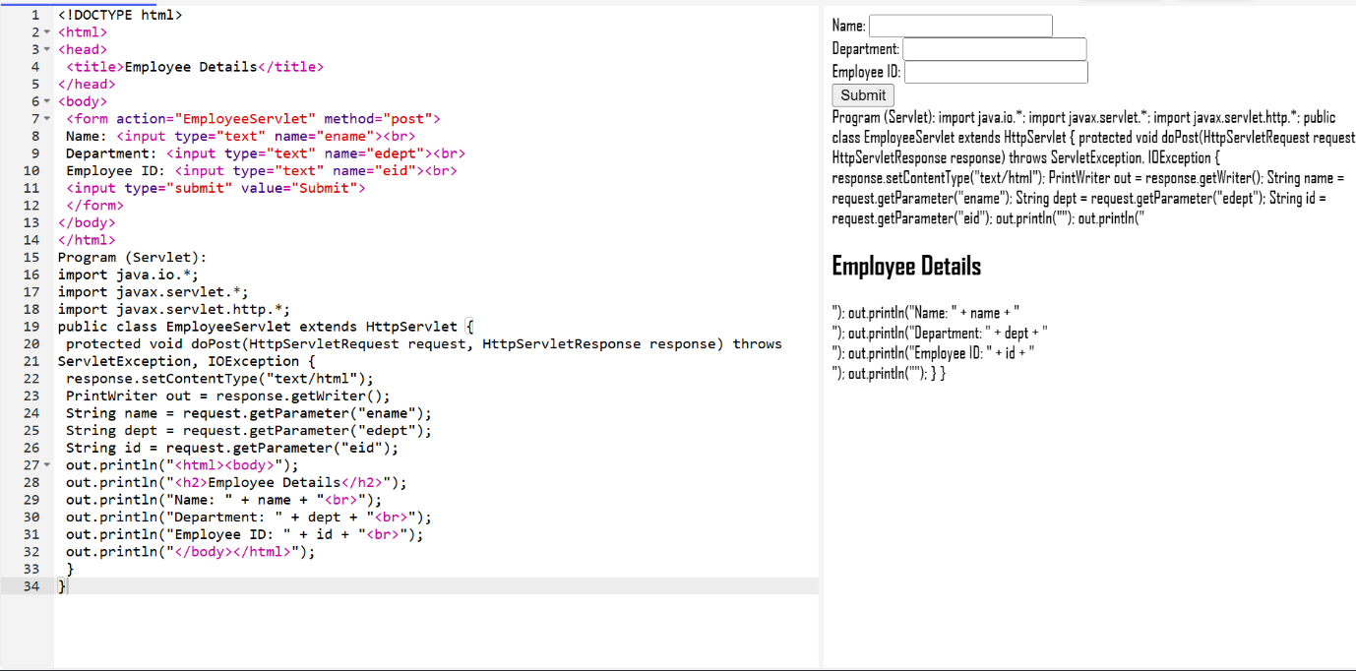

EXERCISE 16:

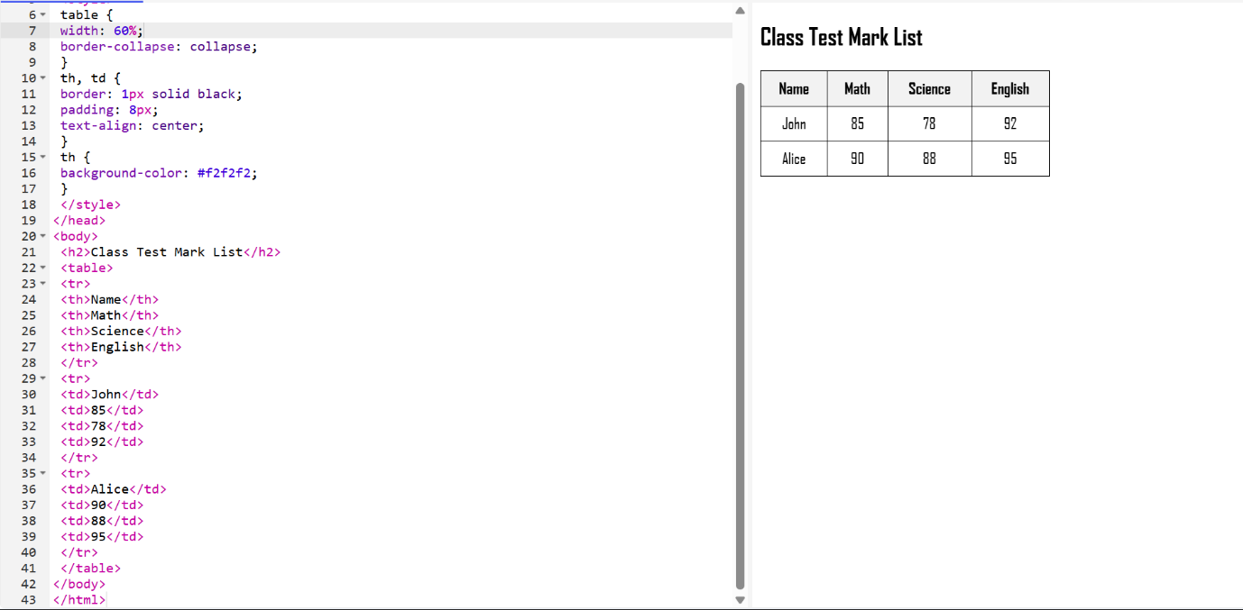

EXERCISE 17:

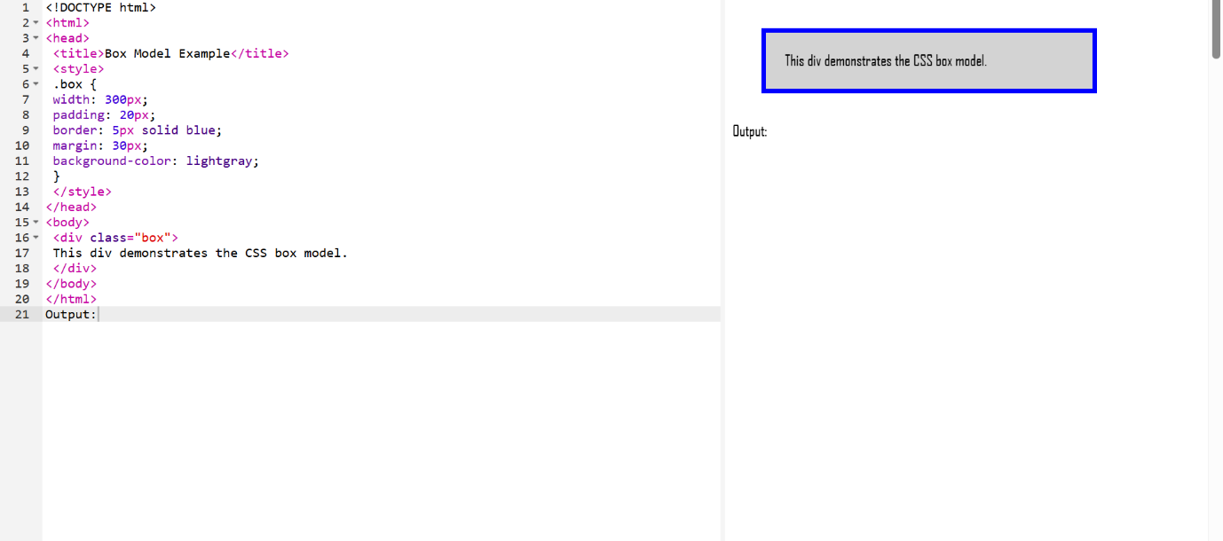

EXERCISE 18:

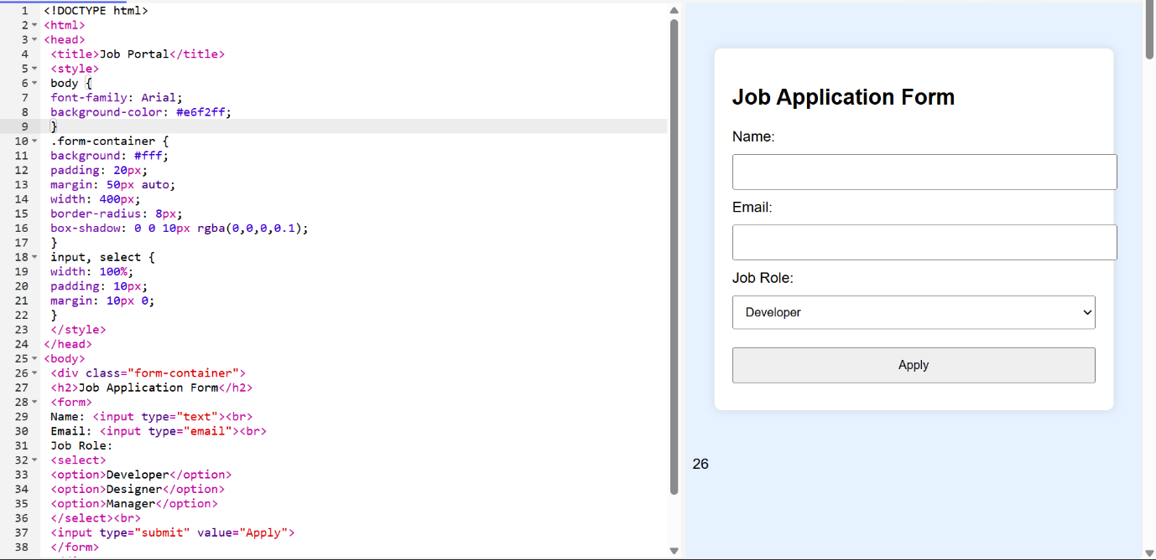

EXERCISE 19:

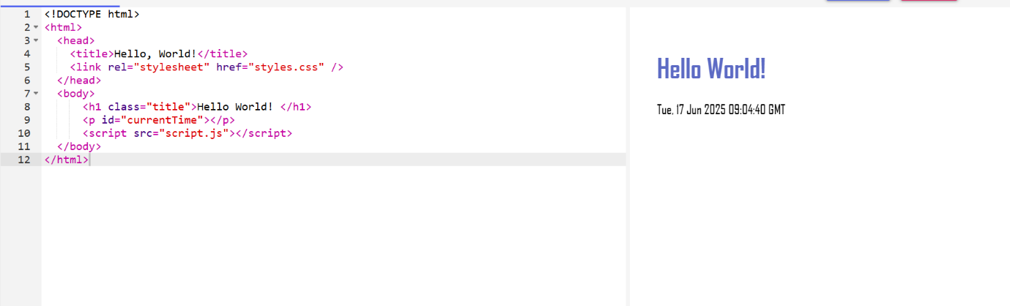

EXERCISE 22:

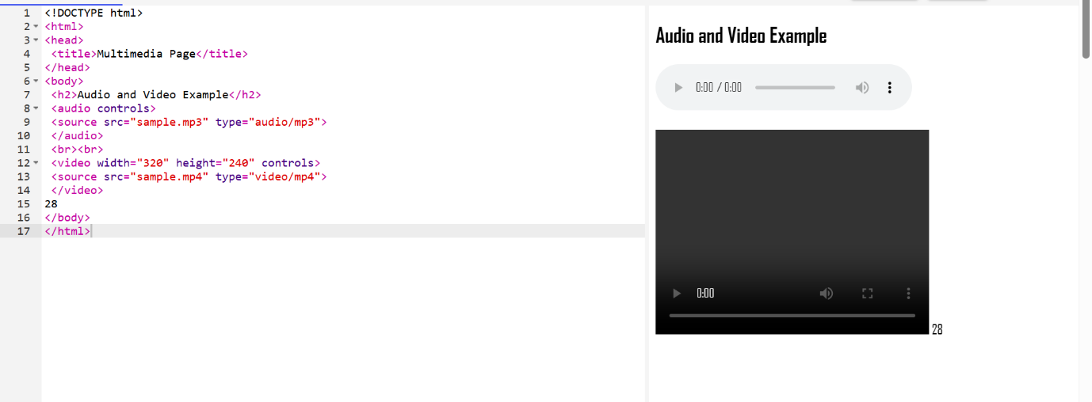

EXERCISE 23:

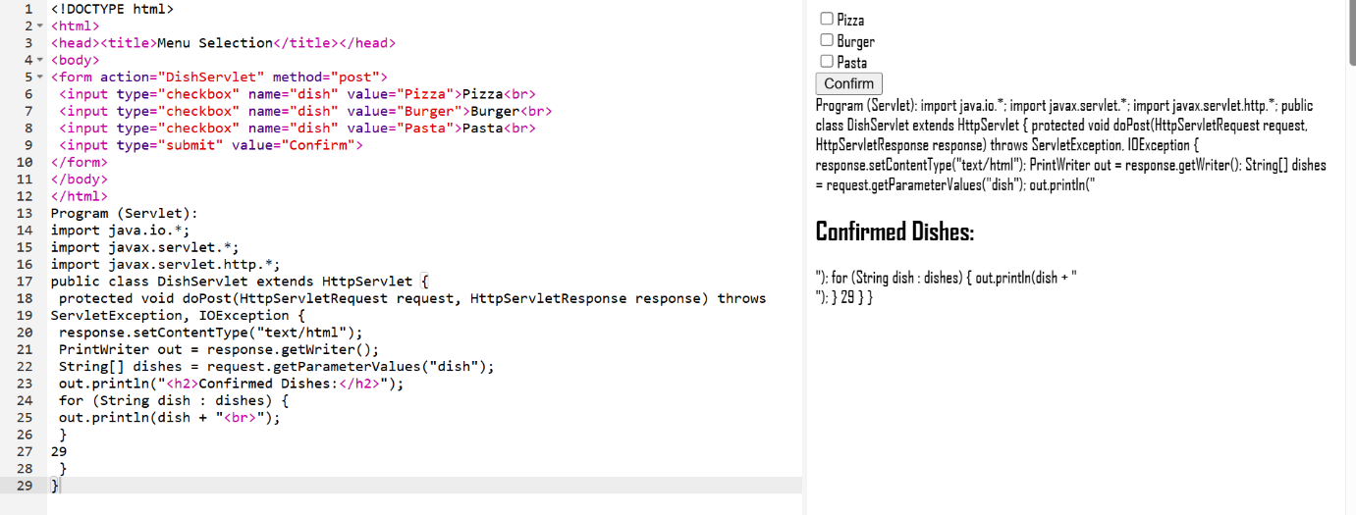

EXERCISE 24:

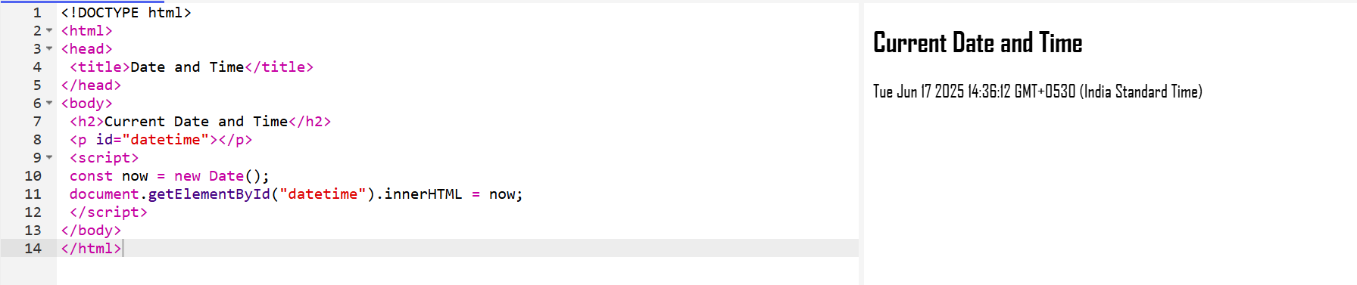

EXERCISE 23:

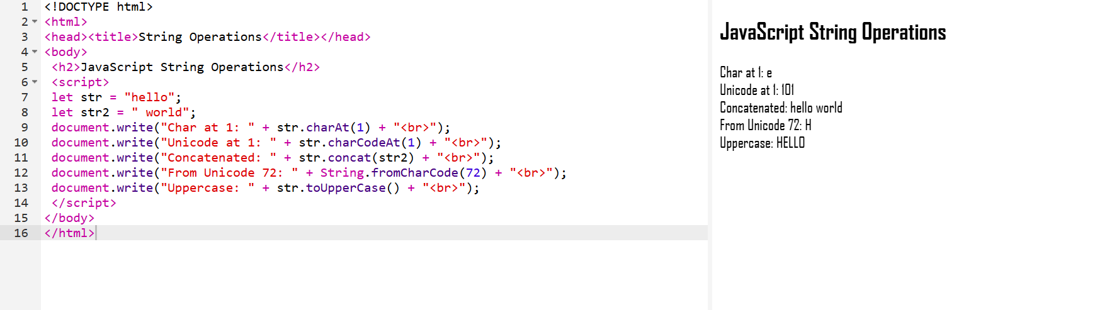

EXERCISE 24:

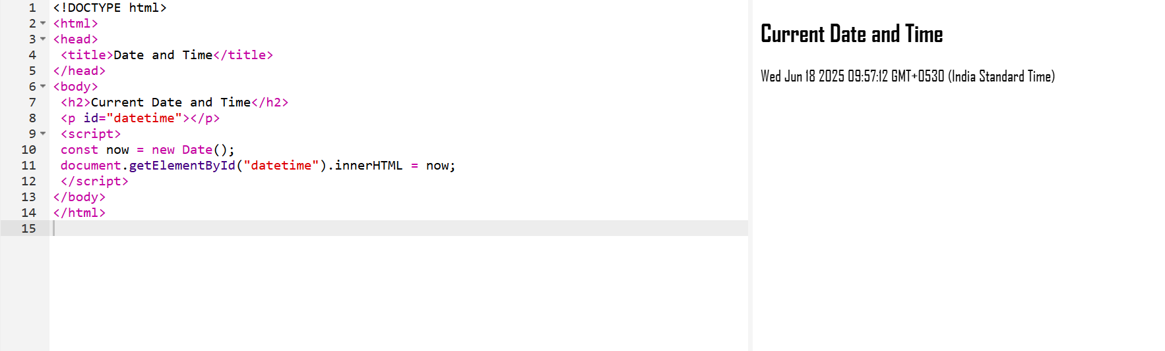

EXERCISE 25:

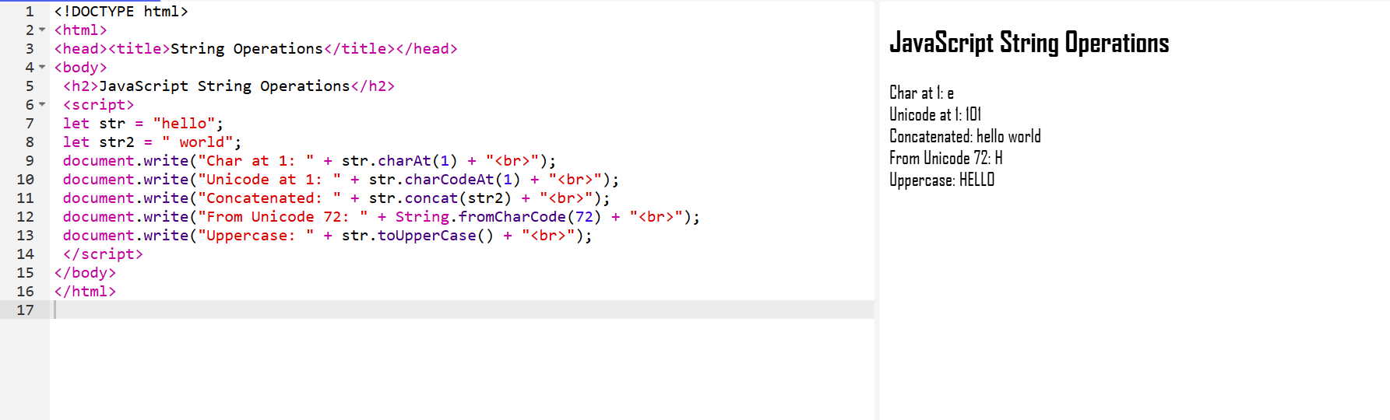

EXERCISE 26:

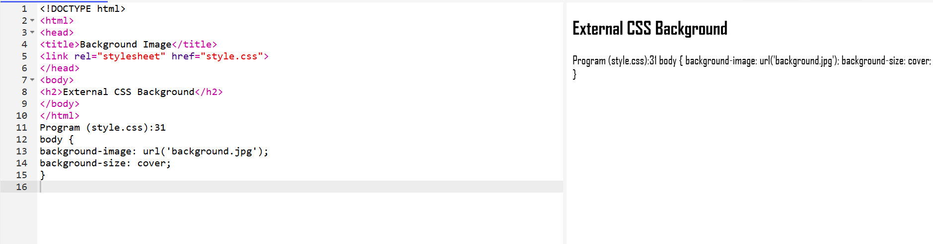

EXERCISE 27:

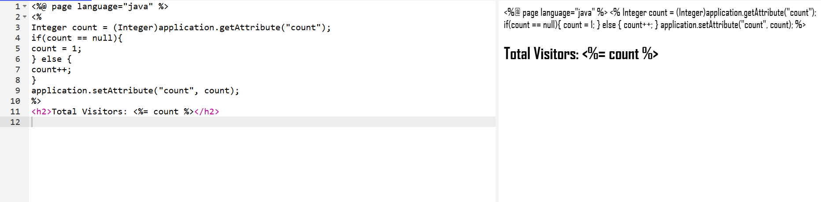

EXERCISE 28:

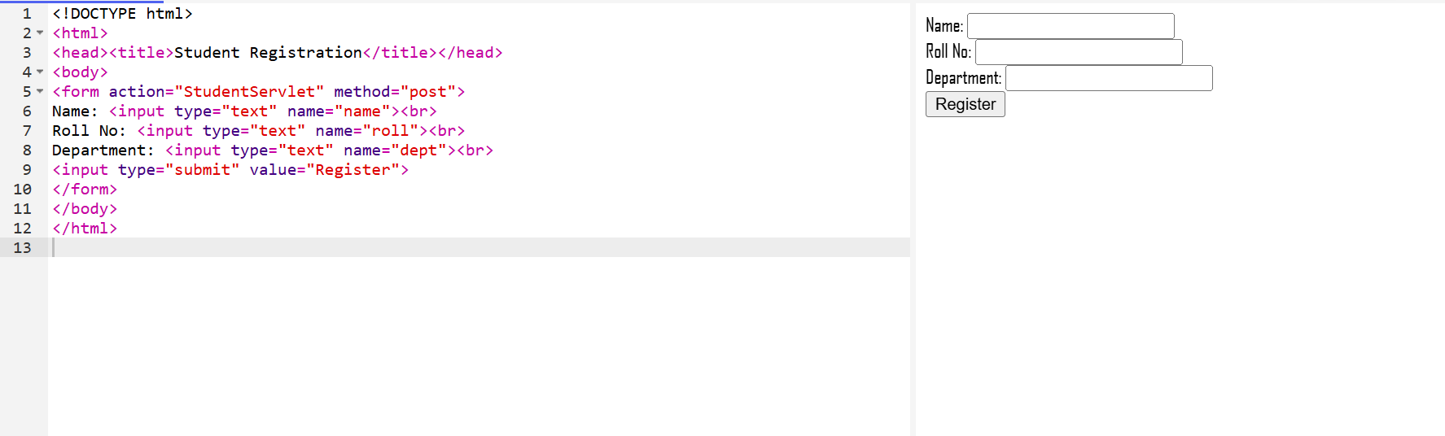

EXERCISE 29:

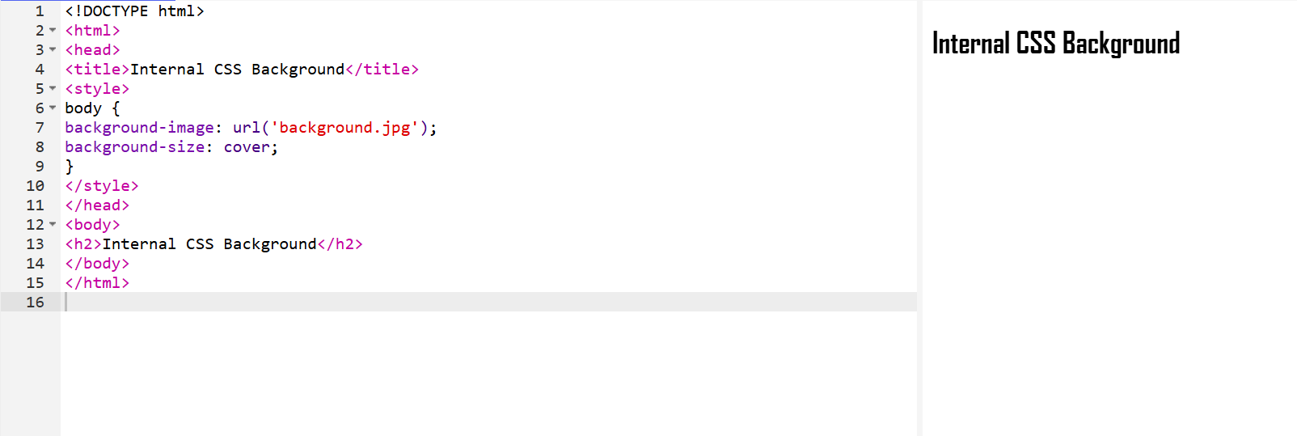

EXERCISE 30:

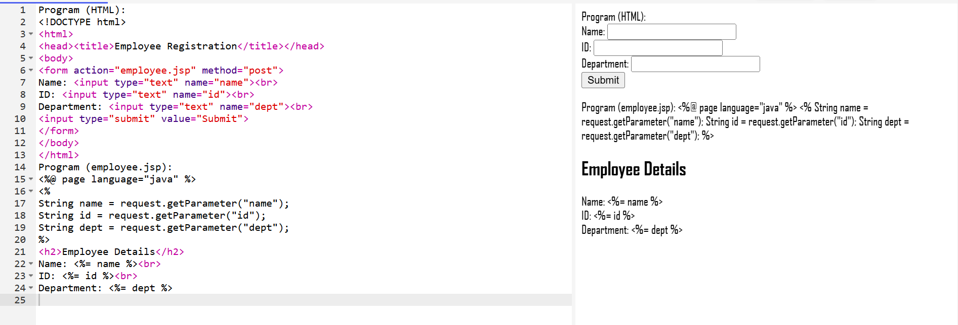

EXERCISE 31:

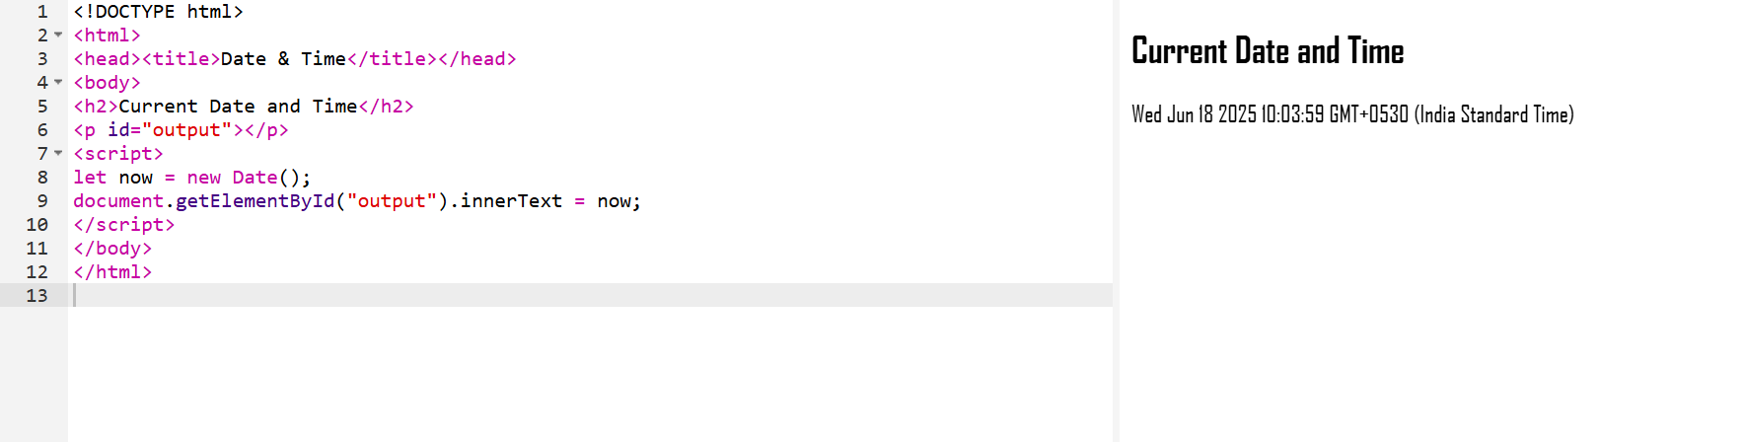

EXERCISE 32:

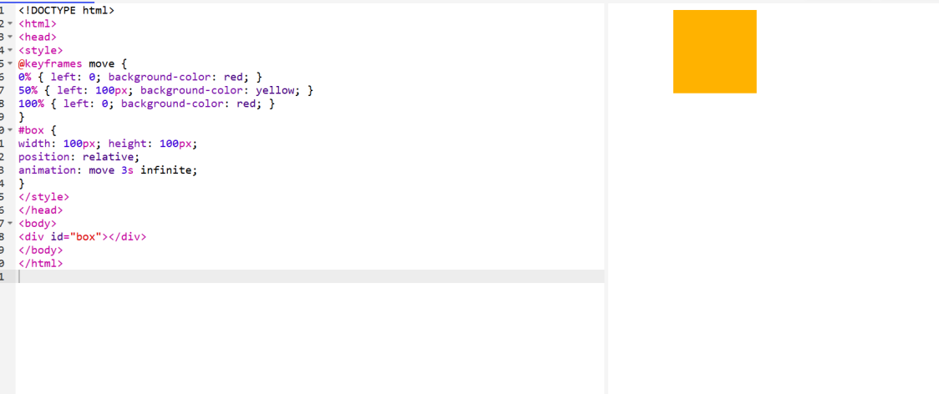

EXERCISE 33:

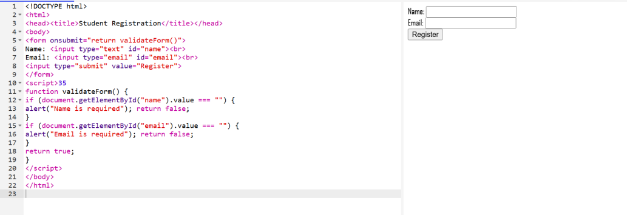

EXERCISE 34:

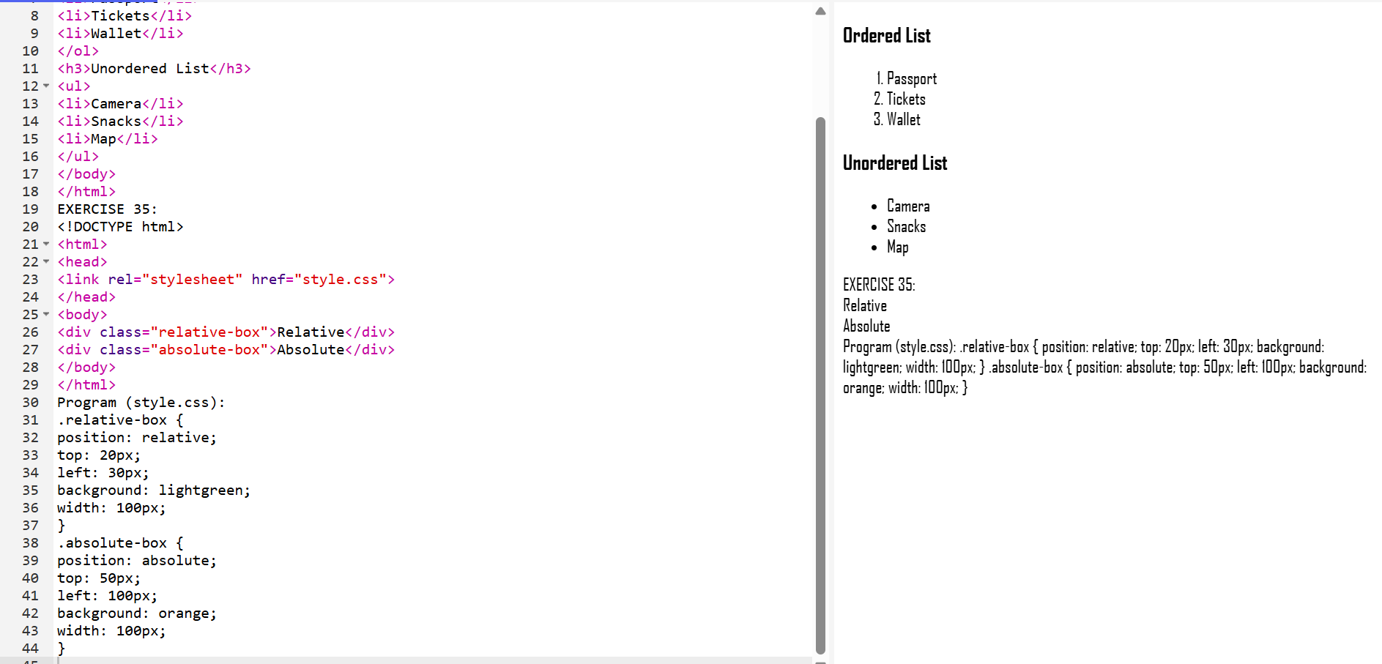

EXERCISE 36:

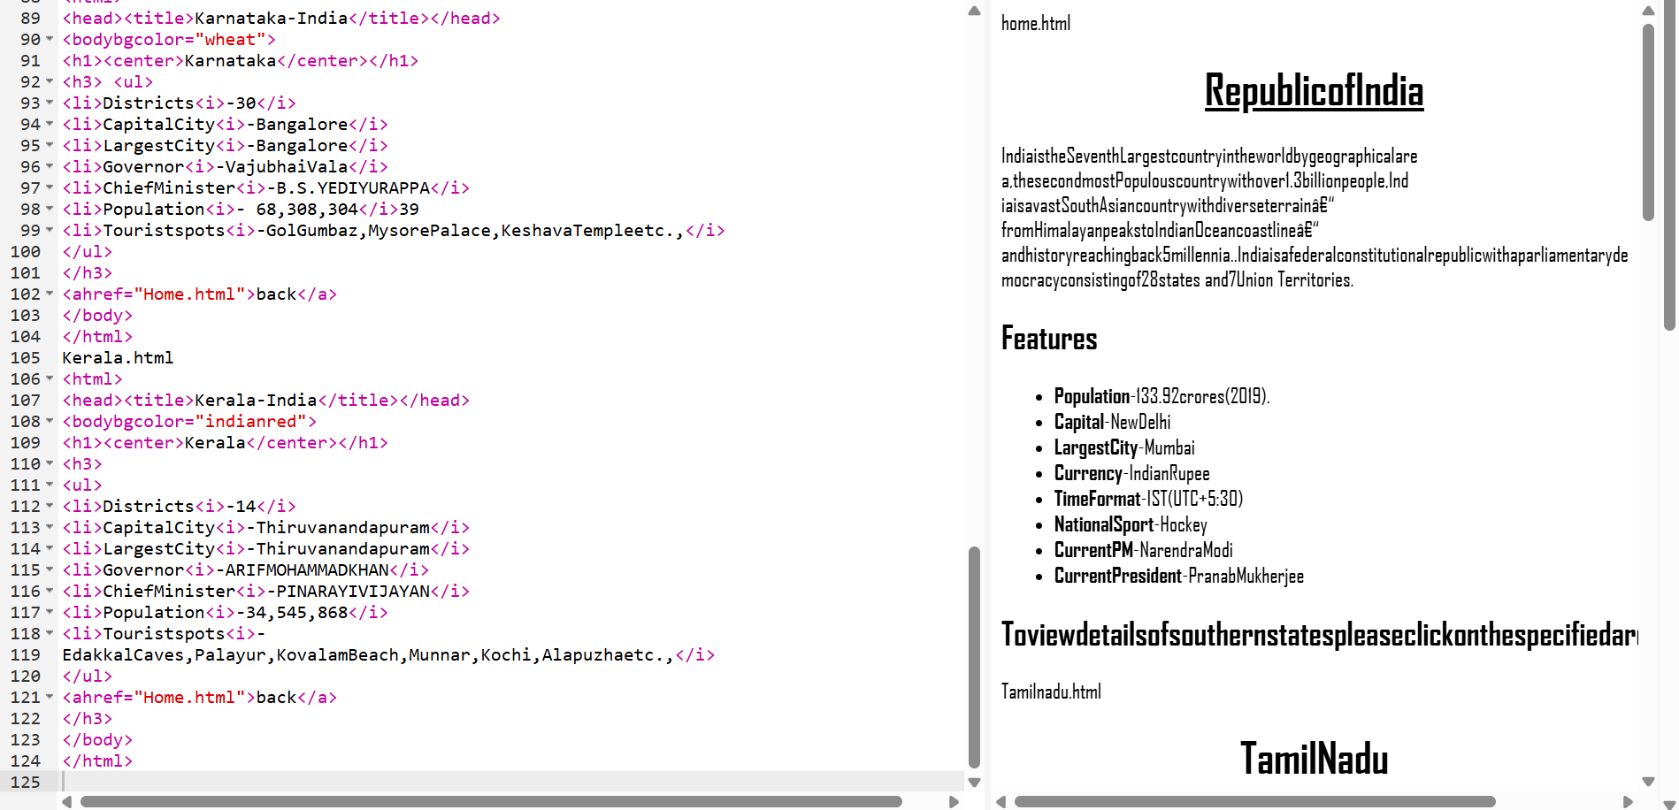

EXERCISE 37:

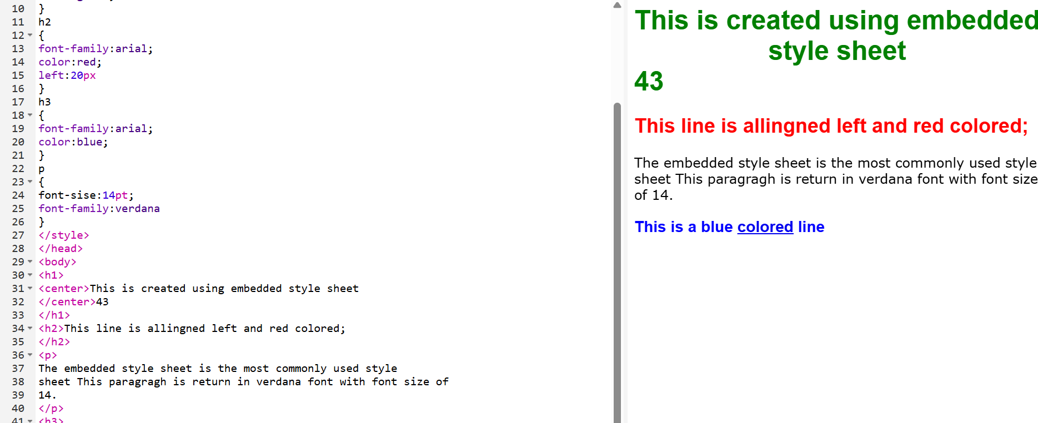

EXERCISE 38:

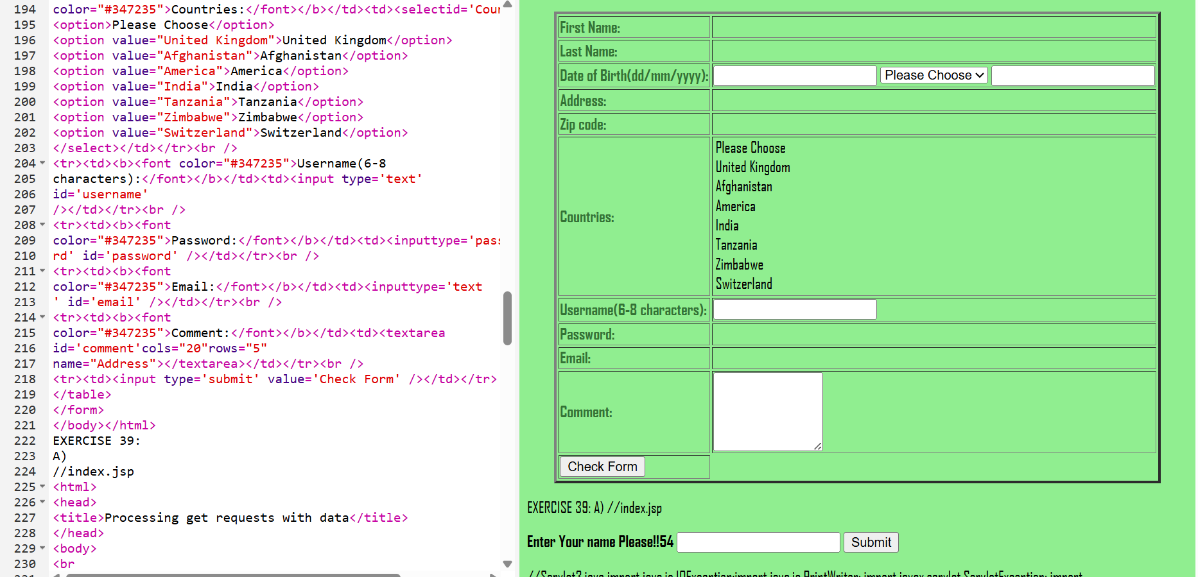

EXERCISE 40:

A)

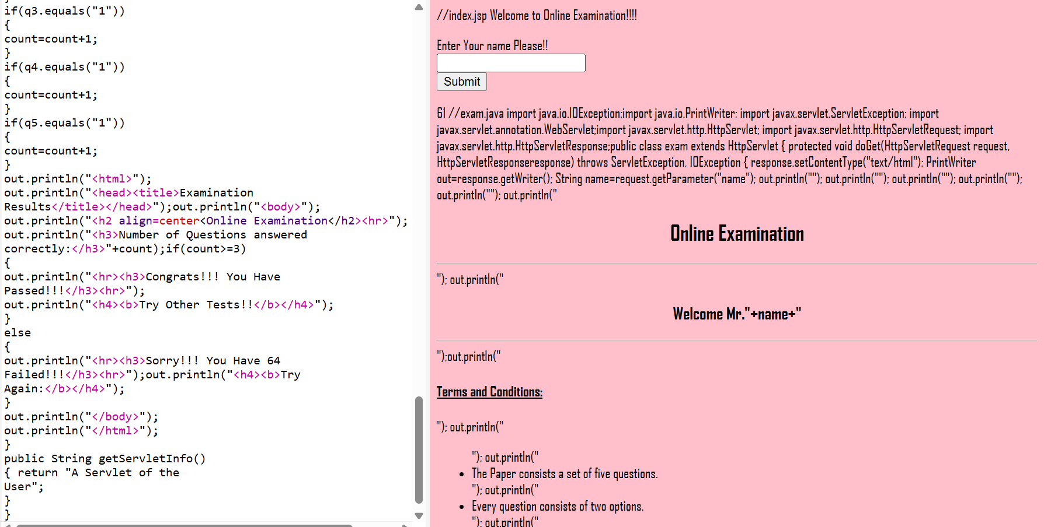

EXERCISE 40:

B)

